Gloeotrichia pisum Thuret ex Bornet & Flahault 1886
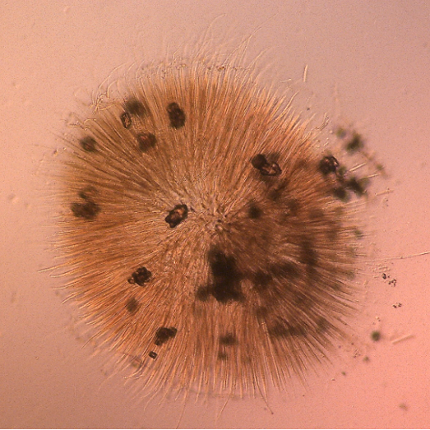
Phylum: Cyanobacteriophyta
Class: Cyanophyceae
Order: Nostocales

Habitat: benthic (epiphytic), littoral
Distinctive features: half pompon-shaped hemisphaerical epiphytic colonies made of many filaments embedded in firm mucilage.
Organization: colonial
Color: dark khaki brown
Cell shape: cylinder
Colony shape: half sphere, made of an aggregate of filaments
Cell diameter (D): 4-7 μm
Cell length (L): 4-12 μm
Cell biovolume: 100 – 350 μm³
Biovolume equation: Cylinder, V, μm³ = π L (D/2)²
Filament length: hundreds of microns
Colony diameter: 0.1–1.5 cm

Morphological features: Hemisphaerical colonies that are attached to plant material, (usually branches of Phragmites australis, but not exclusively) several mm or even cm in diameter, i.e. large enough to be seen with a naked eye (Plate 1). The colonies are khaki-brown, hard and slimy to the touch, they peal off the stems with slight pressure. Young colonies distant from other ones on the same stem are mostly perfect hemispheres (Plate 1A); when in masses the colonies form a continous mantle with rounded margins (Plate 1B). Colonies are made of thin, long cylindrical filaments, embedded in firm mucilage. The filaments adher to a common center, giving the colony a shape of half a pompon (Plate 2). The individual filaments, also called trichomes, begin with a spherical heterocyte located towards the inside of the colony (Plate 3); the apical cell is conical and ends in a hair that extends beyond the sheath (Plate 4). Akinetes are cylindrical, smooth, colorless and are placed next to the basal heterocyst.
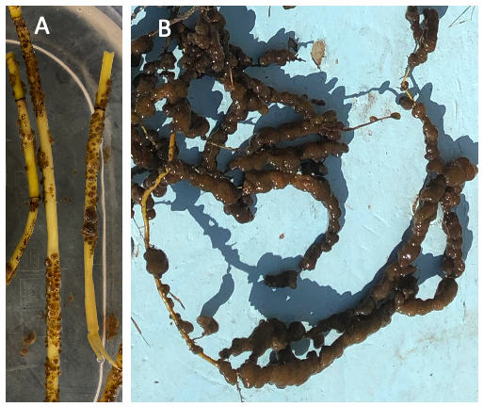
Plate 1. Macroscopic epiphytic colonies of Gloeotrichia pisum from the littoral zone of Lake Kinneret. (A) young colonies on dead branches of Phragmites australis; (B) mature colonies on Adventitious roots of Tamarix jordanis. Photos by Tamar Zohary, 2021-2022.

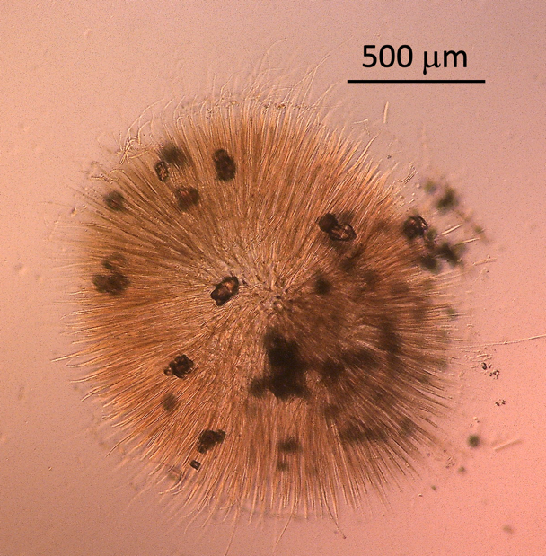
Plate 2. The colonial nostocalean cyanobacterium Gloeotrichia pisum from Lake Kinneret, Israel, showing typical half pompon shape made of many trichomes. Each trichome begins with a heterocyte at the colony center and tapers to a fine hair that extends beyond the colony at its other end. We didn’t figure out what are the dark granular particles scattered around the colony. Photo by Alla Alster.
Plate 3. Close-up on individual filaments of Gloeotrichia pisum. Each filament begins with a spherical heterocyte directed toward the center of the colony.

Plate 4. Close-up on the tapering, delicate end-parts of individual filaments of Gloeotrichia pisum.

Ecology: With climate change, the relative importance of benthic cyanobacteria is mounting. With increased amplitude of water level fluctuations in Lake Kinneret, littoral zone habitats are changing as well as their biota (Zohary and Gasith 2025). Following a rapid rise of lake water level due to a high rainfall winter, in summer 2020 Gloeotrichia pisum appeared as an abundant epiphyte on recently inundated stems of Phragmites australis. This was the first time this species was recorded to occur in Israel (Lang-Yona et al. 2023).
Genomic community composition analysis revealed that G. pisum colonies host a diverse microbial community of microalgae, cyanobacteriophyta, bacteria, and archaea with a conserved and characteristic taxonomic composition.

Physiological features: Fixes atmospheric nitrogen. High phycoerythrin content provides a brownish color and supports growth at low light levels. Found negative in tests for presence of genes for biosynthesis of the toxins anatoxin, cylindrospermopsin and microcystins.
Environmental conditions: Epiphytic on inundated branches of Phragmites australis. Found also on adventitious roots of Tamarix sp. and other hard surfaces.

Cite this record as:
Tamar Zohary, Alla Alster. [Date when Item was last updated]. Electronic publication. Israel Oceanographic & Limnological Research. [Date when last accessed].
Further reading:
Lang-Yona N, Alster A, Cummings D, Freiman Z, Kaplan-Levy R, Lupu A, Malinsky-Rushansky N, Ninio S, Sukenik A, Viner-Mozzini Y, Zohary, T. 2022. Gloeotrichia pisum in Lake Kinneret: a successful epiphytic cyanobacterium. Journal of Phycology 59: 97-110. DOI: 10.1111/jpy.13301.

Zohary T, Gasith A. 2025. Opinion: Climate change-driven water level regimes regulate lakeshore structure and function. Inland Waters 15: 2480886. https://doi.org/10.1080/20442041.2025.2480886

